Frequently Asked Questions

Version 0.5

**Q1**: How to resolve “Could not resolve host: olcentgbl.trafficmanager.net; Unknown error” during PCoIP license server installation?

**A**: When you run command *sudo yum install wget* during PCoIP license server installation and observe below error:

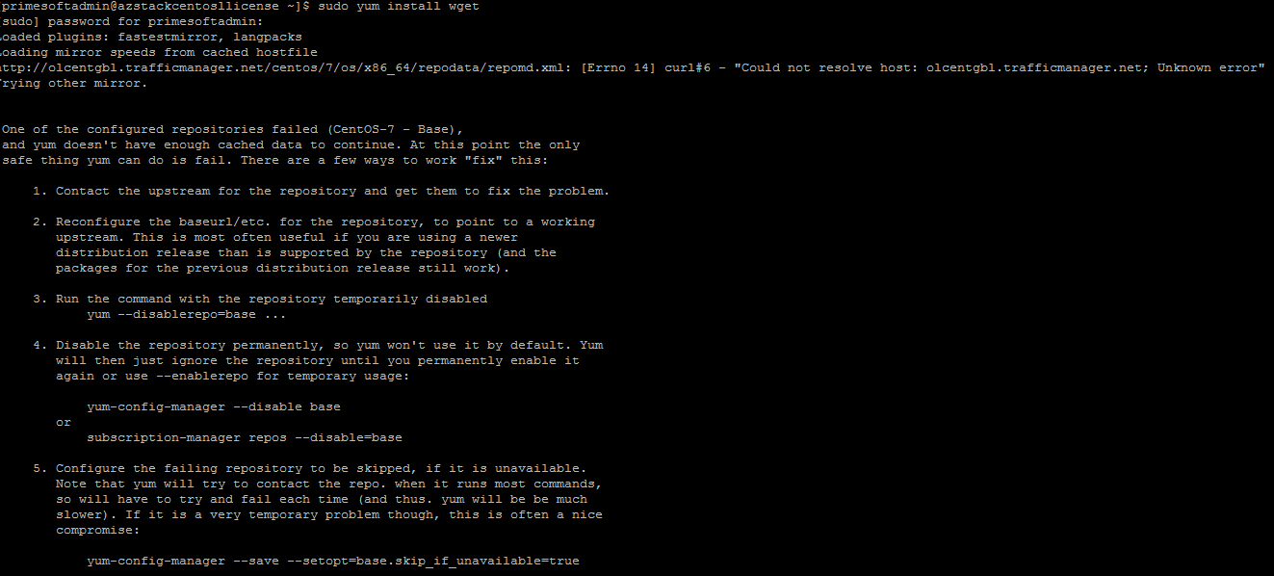

**Solution**:

*cd /etc/*

*vi resolv.conf*

Edit nameserver ip address to domain controller private ip address

Run the command *sudo yum install wget*

**Note**: Make sure you are a root user.

**Q2:** How to resolve “Error downloading packages” during installation of PCoIP license server?

**A**: When you run *sudo yum install -y pcoip-license-server* and observe below error:



**Solution**:

Re-execute the same command *sudo yum install -y pcoip-license-server* to resolve the issue.

**Q3**: How to resolve “No static IP addresses were found on this computer” warning during installation of Active Directory Domain services on Windows virtual machine?

**A**: If you observe “No static IP addresses were found” warning message during installation of AD domain services on windows VM:

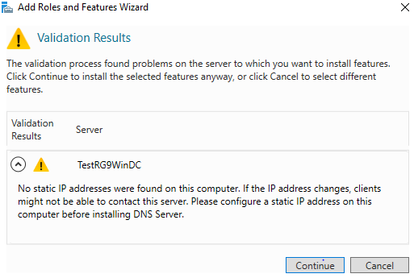

**Solution**:

When this warning message displays, change dynamic IP of Domain controller virtual machine to static IP.

**Note**: After changing to static IP also, if this warning message displays, you can ignore and continue with rest of the steps.

**Q4:** How to resolve “unable to resolve host xxx: Resource temporarily unavailable” error during installation of PCoIP agent on Ubuntu?

**A**: During PCoIP agent installation, when you run command *sudo apt-key adv --keyserver pool.sks-keyservers.net --recv-key 67D7ADA8* and observe below error:



**Solution**:

*sudo su*

*vi /etc/hosts*

Please make sure you have the following lines:

127.0.0.1 localhost

127.0.1.1 localhost myhostname

Change myhostname to your machine name (e.g. TestUbuntu) as shown below:

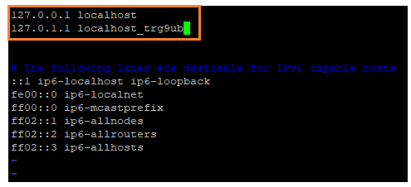

**Q5**: How to resolve “Couldn’t join realm: Necessary packages are not installed” error when joining Ubuntu virtual machine to AD domain?

**A:** To join Ubuntu virtual machine to AD domain, when you run following command

*realm join --verbose --user=****xxx*** *--computer-ou=OU=****Linux****,DC=****xxx****,DC=****xxx*** *10.2.0.132*

and observe following error:

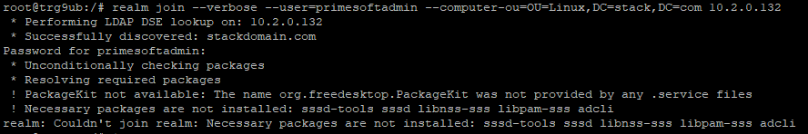

**Solution:**

Run following command:

*apt-get install realmd packagekit*

**Q6:** How to resolve “Could not connect to any server: xxx” error during installation of Cloud Access Connector (CACv2) software in Ubuntu virtual machine?

**A:** When you run following command to install CACv2 software and observe below error:

*sudo ./cloud-access-connector install -t $token --insecure*

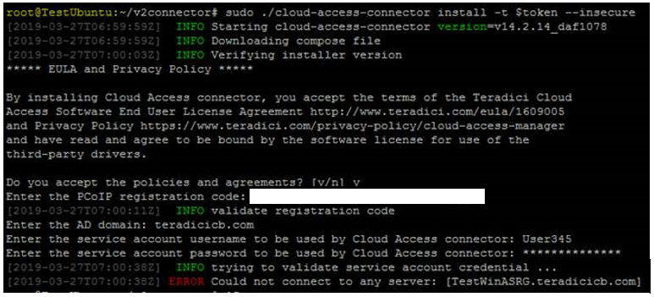

**Solution:** Configure DNS server and netplan before you install CACv2 software

* Edit */etc/systemd/resolved.conf*, uncomment the DNS and Domains lines and use the Domain Controller’s internal IP address and the Domain handled by the Domain Controller:
* Go to resolved.conf file location: Enter *cd /etc/systemd/*
* Edit resolved.conf file: Enter *vi resolved.conf*, click Insert button, uncomment (remove #) and add DNS=IP address (Private) of Domain Controller and Domains=Domain Name

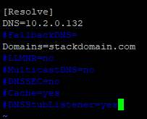

* Click on Esc button
* Enter :wq
* Restart resolved service

*systemctl restart systemd-resolved.service*



* To configure netplan, edit the /etc/netplan/50-cloud-init.yaml file:

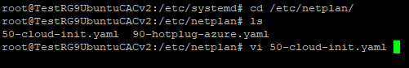

* + Click on Insert button
* Enter nameservers:

addresses: [10.2.0.132]

search: [stackdomain, stackdomain.com]

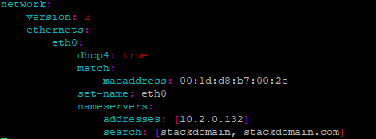

**Note**: Please ensure that alignment and spacing is exactly as shown above.

Click on Esc button

Enter *:wq*

* Enter *netplan apply*



* Restart the resolved service

*systemctl restart systemd-resolved.service*



You should now be able to ping the domain controller (remember to open Windows firewall to ping) and workstations from the CAC VM.

**Q7**: How to resolve “Couldn’t join realm: Failed to join the domain” error on joining Ubuntu virtual machine to AD domain?

**A:** When you run following command and observe below error:

*realm join --verbose --user=****xxx*** *--computer-ou=OU=****Linux****,DC=****xxx****,DC=****xxx******10.2.0.132***

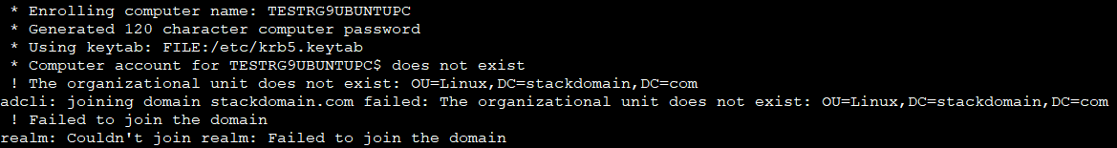

**Solution**:

Run following command:

*sudo realm --verbose join* ***stackdomain.com*** *\*

*--user-principal=trg9ub/****primesoftadmin@STACKDOMAIN.COM*** *–unattended*

**Q8**: How long will it take to create a virtual network gateway?

**A**: Creating a virtual network gateway can take up to 45 minutes. Once virtual network gateway is create, it appears as a connected device. You can click the connected device (your virtual network gateway) to view more information.

**Q9**: How long will it take for the Site-to-Site VPN connection to establish?

**A:** Once the connections are setup in each gateway the Site-to-Site VPN connection will be established. It may take up to 45 minutes for the Connection status to display as “Connected,” but usually it will take around 15 minutes.

**Q10:** How to resolve “The address space ‘xx.x.x.x/xx' overlaps with 'xx.x.x.x/xx' in virtual network 'xxxVnet'” warning message while creating virtual network?

A: Provide a different address space that is not defined for any other virtual networks.

**Example**: Enter address space as 10.3.0.0/16 when 10.2.0.0/16 is already defined for other virtual network.

**Q11**: Which IP address we need to provide to set up DNS server for a virtual network?

**A:** Once static IP is configured for Domain Controller VM, set the DNS Server for the Azure Stack Deployment by following below steps:

* Click on Virtual Network of Azure Stack
* Click on “DNS Servers” option in left pane and select “Custom” radio button in right pane and enter DNS Server IP (private IP of Domain Controller VM)

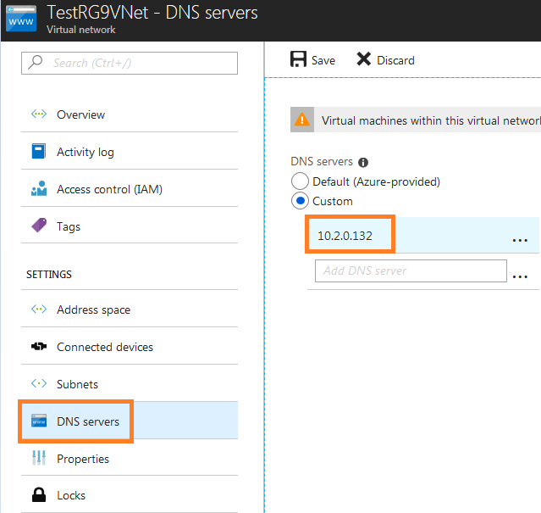

* Navigate to Virtual Network of Azure Stack and check the DNS Server

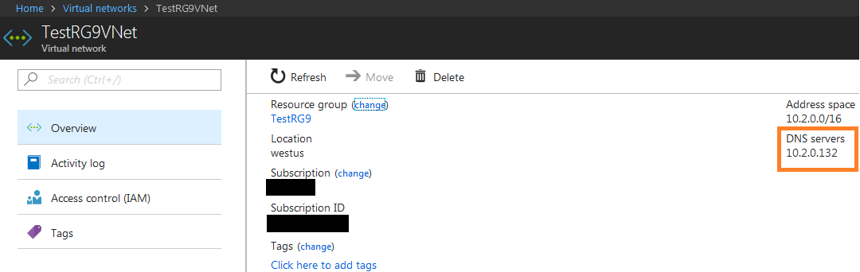

**Q12:** Which size is recommended to set up Active Directory Domain Services on Windows VM?

**A:** Selecting size DS2_V2 is recommended to setup AD domain services on Windows VM.

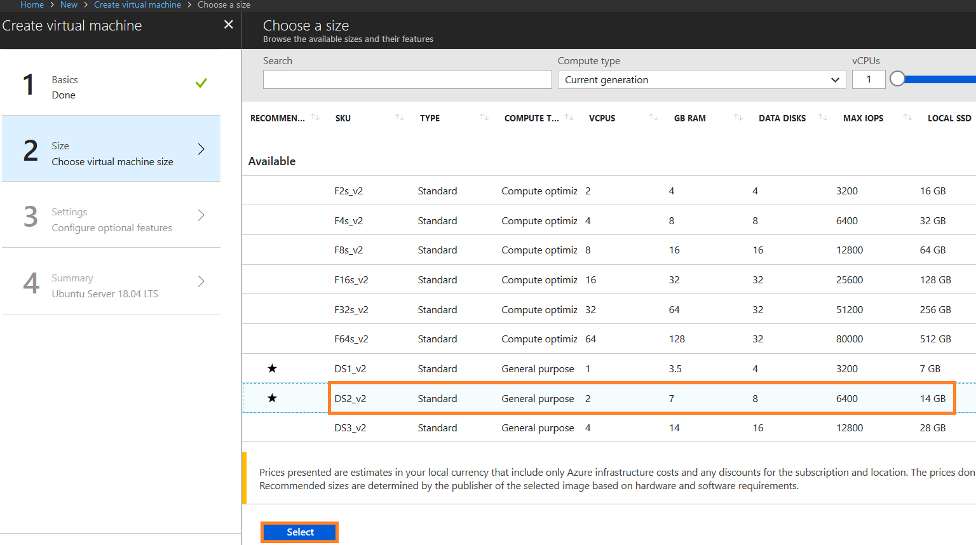

**Q13:** How to resolve issue with downloading Cloud Access Connector (CACv2) component files from Teradici folder?

**A:** When you run following commands, but could not download the CACv2 component files:

*mkdir ~/v2connector && cd ~/v2connector*

*curl -LO https://teradici.bintray.com/cloud-access-connector/cloud-access-connector-0.1.1.tar.gz*

*tar xzvf cloud-access-connector-0.1.1.tar.gz*

**Solution**:

If you are unable to download CACv2 component files for the first time, please re-execute the same commands again. Upon successful download, it will look like the following:

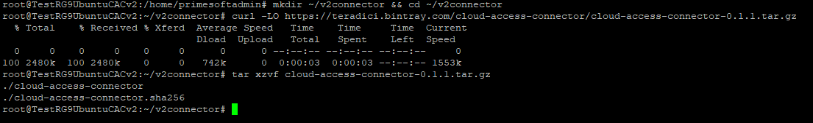

**Q14:** What is the expiration period of Authorization token generated for a new deployment?

**A:** The Authorization token will expire after 2 hours. If this occurs you will need to get a new token.

**Q15:** During CACv2 installation, when the user is prompted with message as “Enter the Distinguished Name for the User Group to log into the CAM Management Interface. Default is ‘Domain Admins,’ how to choose ‘Domain Admins’ option?

**A:** At this point, just hit “Enter” to choose default ‘Domain Admins’ option.

**Q16:** During CACv2 installation, when the user is prompted with message as “Enter the Distinguished Name for the User Group to log into the CAM Management Interface. Default is ‘Domain Admins,’ from where we need to enter the Distinguished Name?

**A:** To enter Distinguished DC Name, go to DC -> Server Manager -> Tools -> Active Directory Users and Computers -> View -> Advanced Features -> Users (in Right pane) -> Domain Admins right click-properties -> Attribute editor -> copy Distinguished Name (CN=Domain Admins,CN=Users,DC=azurestackdemo,DC=com) from this location.

**Q17:** How to identify license activation code and what is the format of it?

**A:** Activation codes only apply to individual licenses installed on a license server.

Your company or department is assigned one unique and confidential Cloud Access registration code. Format: X@Y where X is the License Server ID and is unique to your organization; Y is the secret activation code.

Example of cloud access registration code: ABCDEFGH12@AB12-A123-A12B-12AB

Example of license activation code: AB12-A123-A12B-12AB

**Q18**: What is the Powershell script to register and validate cloud license configuration?

**A:** If you are using Cloud Licensing, register the PCoIP agent's license by running the **pcoip-register-host.ps1** script: C:\Program Files (x86)\Teradici\PCoIP Agent\pcoip-register-host.ps1

To validate cloud license configuration run **pcoip-validate-license.ps1**: C:\Program Files (x86)\Teradici\PCoIP Agent\pcoip-validate-license.ps1

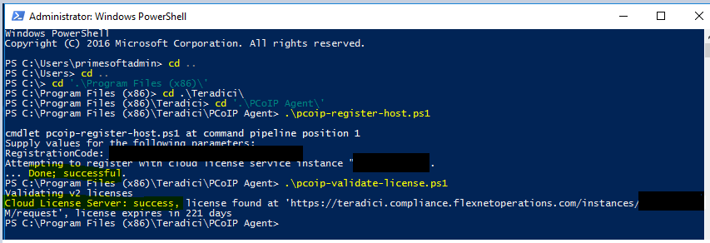

**Q19**: How to update Cloud Access Connector software to the latest version?

**A:** To update Cloud Access Connector software to the latest version, navigate to ~/v2connector directory and run command ./cloud-access-connector update

**Q20. How to resolve “Broker failed to allocate resource” error in PCoIP Client in case of a DNS issue?**

**A:** To resolve“Broker failed to allocate resource” error, configure the following in Domain Controller:

Domain Controller VM: Windows Administrative Tools -> DNS -> DC VM name (e.g. TESTRG9WINDC)-> Forward Lookup Zones -> Domain -> Create Host (e.g. trg9ub).

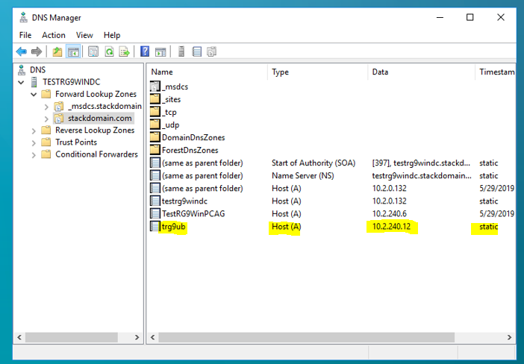

After configuring host, you will be able to ping Agent VM name (e.g. trg9ub) and FQDN (e.g. trg9ub.stackdomain.com)

**Q21:** How to create PCoIP Support Bundle for troubleshooting?

**A:** Execute **pcoip-support-bundler** command on agent virtual machine.

PCoIP agent support bundle will be created:

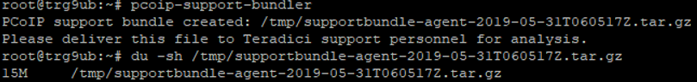

**Q22:** What is the path to view broker logs in CACv2 virtual machine?

**A:** You can view broker logs in the following path:

*/var/lib/docker/overlay2/xxxxx/merged/usr/local/tomcat/logs/broker/log.out*

Run the following commands:

*cd /var/lib/docker/overlay2/xxxxx/merged/usr/local/tomcat/logs/broker*

*cat log.out*

**Q23:** What is the path to view agent logs in Ubuntu Agent virtual machine?

**A:** You can view agent logs in the following path:

*/var/log/pcoip-agent/agent.log*

Run the following commands:

*cd /var/log/pcoip-agent*

*cat agent.log*

**Q24:** What is the path to view PCoIP connection manager logs in CACv2 virtual machine?

**A:** You can view PCoIP Connection Manager logs in the following path:

*/var/lib/docker/overlay2/xxxxx/merged/var/log/Teradici/ConnectionManager/pcoip-connmgr_xxx.log*

Run the following commands:

*cd /var/lib/docker/overlay2/xxxxx/merged/var/log/Teradici/ConnectionManager*

*cat pcoip-connmgr_xxx.log*

**Q25:** What is the path to view PCoIP client event logs?

**A:** You can view PCoIP client event logs in the following path:

*C:\Users\Username\AppData\Local\Teradici\PCoIPClient\logs*

**Q26**: How to navigate to SecurityGateway.conf file in CACv2 virtual machine and verify Public IP address in the file?

**A:** Run following commands:

*docker ps –a*

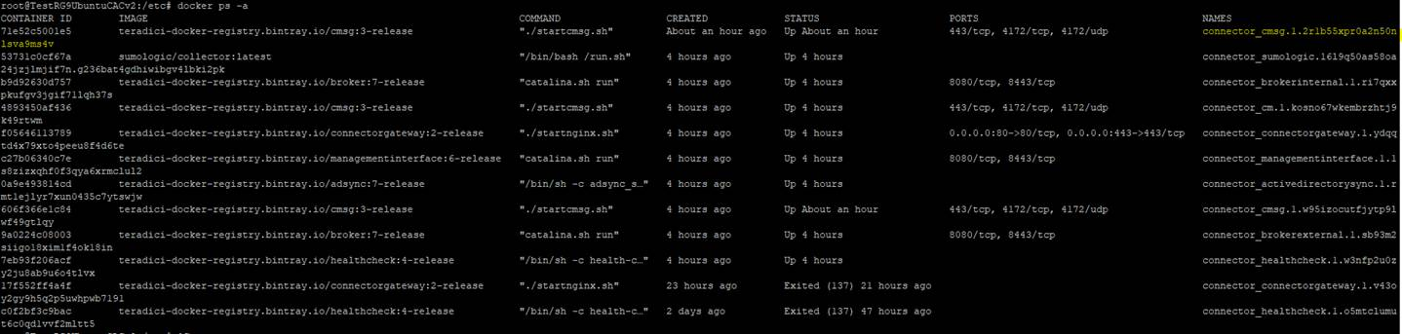

*docker cp connector_cmsg.1.xxxx:/etc/SecurityGateway.conf ./*



*vi SecurityGateway.conf*

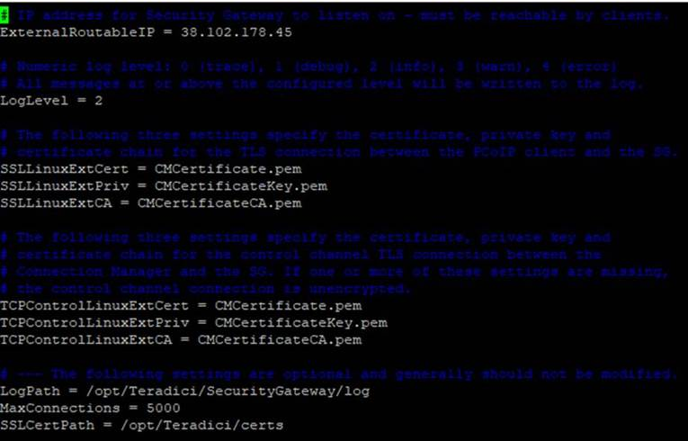

SecurityGateway.conf file should have the same Public IP address as that of CACv2 virtual machine.

**Q27:** What is the path to view to SecurityGateway logs in CACv2 virtual machine?

**A:** Run the following commands:

*docker ps –a*

*docker cp connector_cmsg.1.xxxxx:/var/log/Teradici ./*

*cd ./*

*cd Teradici/SecurityGateway*

*cat SecurityGateway_xxxxx.log*

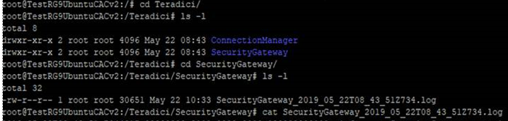

**Q28:** How to resolve “Could not get lock /var/lib/dpkg/lock – open” error?

**A:** When you run command *sudo apt install kubuntu-desktop* and observe below error:

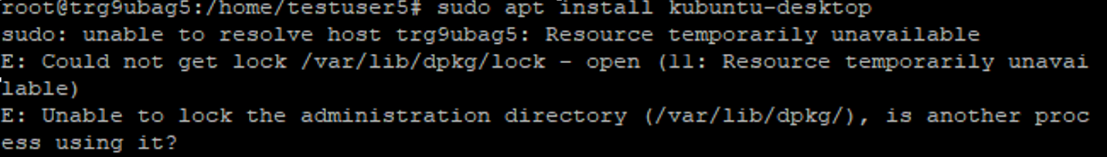

**Solution**: Restart Ubuntu agent machine in Azure Stack and re-execute the kubuntu desktop installation command and issue will be resolved.

**Q29:** How to join Windows Agent virtual machine to Windows Domain Controller?

**A:** Login to Windows Agent virtual machine and navigate to following path and enter domain name.

My Computer -> Properties -> Change Settings -> Change -> Select Domain radio button -> Enter domain name (e.g. stackdomain.com)

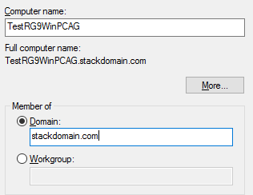

**Q30:** How to verify installation of PCoIP standard agent in Ubuntu virtual machine?

**A:** After installation run command *dpkg –l “*pcoip-agent*”*

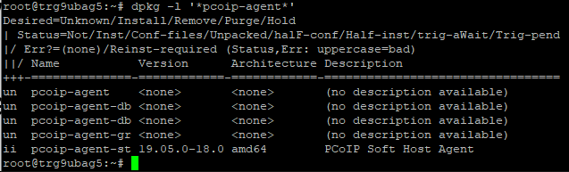

**Q31:** How to resolve following “KDC reply did not match expectations” issue while joining CentOS VM to Domain?



**A:** Enter domain name in upper case as shown below:



**Q32:** How to resolve “Failed to establish a remote session due to invalid username, password, and/or domain” error during establishing PCoIP client session with CentOS or Ubuntu VM?

**A:** Only one user can be logged into virtual machine at a time with PCoIP Client. This error is observed when a user is already logged into virtual machine from PCoIP client and another user tries to login to same virtual machine from PCoIP Client.

To resolve this issue, first user has to log out before second user can login to virtual machine via PCoIP Client.

**Note**: Disconnecting PCoIP client session will not allow other user to login. Other user will be able to login to virtual machine only after log out action is performed.

**Q33:** How to verify whether firewall is blocking 4172 port?

**A:** You can verify by doing a ‘openssl s_client -connect <ip-of-cac>:4172’ and seeing if you get a response. You can try with the internal IP of the CAC from an agent machine and then from an external IP.

Run following commands on agent virtual machine:

*openssl s_client -connect <internal ip-of-cac>:4172*

*openssl s_client -connect <external ip-of-cac>:4172*

**Q34:** How to deprovision Linux virtual machine before capturing the image?

**A:** Connect to your Linux VM with an SSH client.

In the SSH window, enter the following commands:

*bash*

*sudo waagent -deprovision+user*

Click on Stop button for Linux VM in Azure Stack portal.

**Q35:** How to generalize Windows virtual machine before capturing the image?

**A:** To generalize your Windows VM, follow these steps:

* Sign in to your Windows VM.
* Open Run box, (Win + R), enter sysprep and click on OK button.
* Run sysprep.exe
* In the System Preparation Tool dialog box, select Enter System Out-of-Box Experience (OOBE) and select the Generalize check box.
* For Shutdown Options, select Shutdown.
* Select OK.

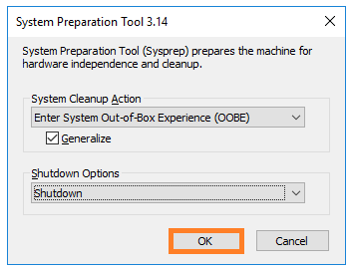

* When Sysprep completes, it shuts down the VM. Do not restart the VM.

**Q36:** How to stop / disable firewall in CentOS 7.5 virtual machine?

A:

You can temporarily stop the FirewallD service with the following command:

*sudo systemctl stop firewalld*

However this change will be valid for the current runtime session only.

To permanently disable the firewall on your CentOS 7 system, follow the steps below:

First, stop the FirewallD service with:

*sudo systemctl stop firewalld*

Disable the FirewallD service to start automatically on system boot:

*sudo systemctl disable firewalld*

The output from the command above will look something like this:

*Removed symlink /etc/systemd/system/multi-user.target.wants/firewalld.service.*

*Removed symlink /etc/systemd/system/dbus-org.fedoraproject.FirewallD1.service.*

**Q37:** How to check firewall status in CentOS 7.5 virtual machine?

**A:** *sudo firewall-cmd –state*

If the FirewallD service is running on your CentOS system the command above will print the following message:

*Running*

**Q38**: How to disable firewall in Ubuntu 18.04 virtual machine?

**A:**

To disable firewall execute:

*sudo ufw disable*

Confirm the firewall status

*sudo ufw status*

**Q39:** How to resolve “Network connection has been lost” error message due to blocked TCP port 4172 during PCoIP client session?

**A: Blocked TCP port 4172**

If the PCoIP Client shows the message "Error: The network connection has been lost" when trying to establish a PCoIP session. This typically means the TCP port 4172 connection was not successfully established between the PCoIP Client and PCoIP Security Gateway or the PCoIP Client and PCoIP agent. If you receive this message when not trying to establish a PCoIP session, the network communication has failed.

To resolve this issue confirm TCP port 4172 is open in all firewalls. During the installation process, the PCoIP Agent will open the required firewall ports in the Windows and Linux operating system default firewalls. If you are using Microsoft Windows, ensure the Windows Firewall service is running and re-install the PCoIP Agent.

Ensure you configure following inbound port rules for CACv2 and PCoIP agent virtual machines.

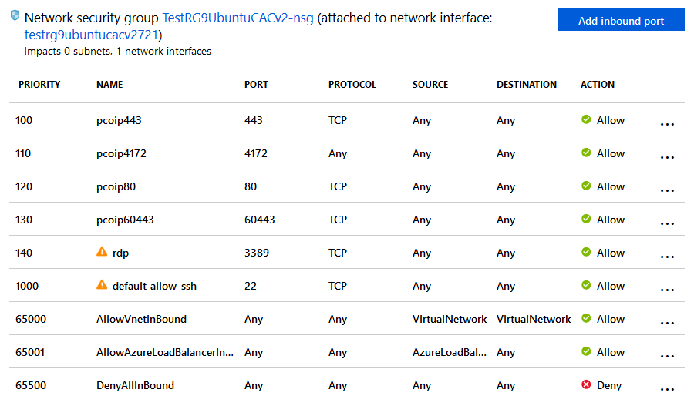

**Q40.** How to resolve issues with installing desktop environment (GUI) on Centos 7.5?

**A:** When you run command *sudo yum groupinstall 'Server with GUI'* to install desktop environment in CentOS and observe following error:

Warning: group Server with GUI does not exist

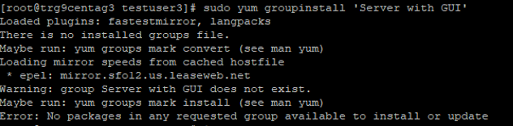

Executecommand *yum group list hidden* to check for available groups.

If MATE Desktop is available in the list, you can execute following command and install MATE Desktop environment:

*yum --enablerepo=epel -y groups install "MATE Desktop"*